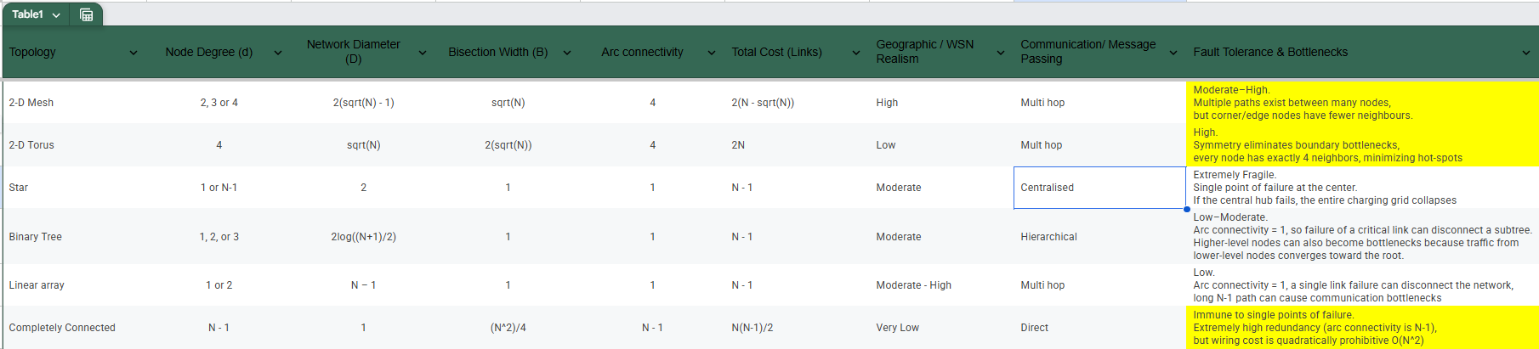
Topology Selection – The chosen network architecture for the EV charging simulation is a hybrid topology combining a 2-D Cartesian Mesh for inter-node communication and a Star topology for base station coordination. This approach perfectly balances the geographical constraints of a physical wireless sensor network (WSN) with the need for immediate centralized data logging.
2-D Mesh for EV Node Interconnectivity
- Geographical Realism: The assignment specifies that charging nodes are positioned in a Cartesian grid and must communicate strictly with immediate adjacent nodes. The 2-D mesh natively maps to this physical layout, accurately simulating the limited radio transmission range of real-world wireless sensors.
- Hardware Efficiency: Wireless sensor nodes operate with constrained hardware. A 2-D mesh restricts the node degree (the number of I/O links per node) to a maximum of 4. This provides multiple communication paths for fault tolerance without requiring expensive, high-degree networking hardware at each charging station.
Star Topology for Base Station Coordination
- Low-Latency Alerts: When an EV node's charging ports exceed the utilization threshold, it must alert the base station to log data and compute redirection routes. Overlaying a Star topology connects every EV node directly to the base station server, minimizing the network diameter for these critical alerts so they do not suffer multi-hop delays across the mesh.
- Delegating the Bottleneck: While a Star topology forces a high node degree (N-1) on the central hub, this hybrid design specifically assigns that burden to the base station. This accurately reflects reality, where a central server has the bandwidth and processing power to handle high traffic, while the edge EV nodes remain lightweight.
Why Alternative Topologies Fail the WSN Realism Test
- 2-D Torus & Completely Connected: A Torus requires wraparound links that assume nodes on opposite geographic boundaries can directly communicate, while a Completely Connected topology requires every node to reach every other node (an O(N^2) link cost). Both violate the physical distance limits of wireless sensors.
- Linear Array & Binary Tree: A Linear Array suffers from a high network diameter (N-1), causing unacceptable transmission latency for a 2D layout. A Binary Tree is highly susceptible to critical link failures disconnecting entire subtrees (arc connectivity of 1) and creates traffic bottlenecks as data moves toward the root.
- Standalone Star: If used exclusively, EV nodes would be forced to route their local neighbor queries through the base station. This violates the requirement to check "immediate adjacent nodes" and creates a single point of failure and massive communication bottleneck at the server.

